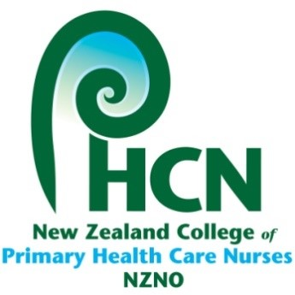
RULES REMIT

RECEIVED FROM:
^{(Name of submitting group)}

Rule Remit – Title:

Rule Remit – Recommendation:

Rationale:

Please ensure the rationale clearly addresses the following:
- the reason for your remit
- what it seeks to achieve and
- the proposed policy remit.
In addition, please consider and clearly outline the potential consequences of the proposed amendment.

Please note that the groups reviewing your proposal will not have the benefit of the discussions that occurred within your group.
Please email all completed remit forms must to primaryhealth@nzno.org.nz

Remits close midday on Friday, 30 January 2026.

